**FALL DETECTION BAND**

**PROJECT REPORT**

**TEAM #3-SECTION 15**

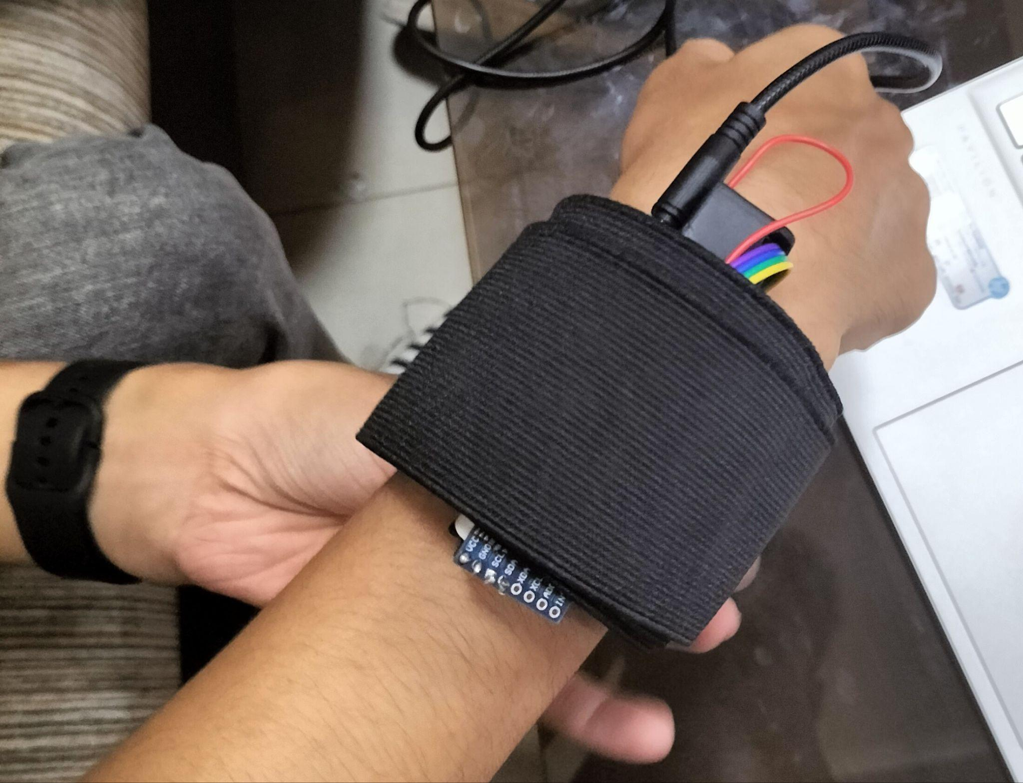

**TEAM MEMBERS-**

**1)Sirsha Banerjee-22NA30031**

**2)Ankush Chatterjee-22EE10009**

**3)Shanampudi Pranaya Chowdary-22CS10070**

**4)Geetansh Gupta -22EE10029**

**INTRODUCTION:**

Falls are a leading cause of injury and hospitalization,especially among the elderly population.According to the WHO,falls are the second leading cause of accidental or unintentional injury death worldwide.

Fall detection is therefore very important.This is because it can notify the medical authorities or family members when it detects falls and reduces the risk of delay in medical attention.IOT based fall detector devices can save lives in an emergency.

The motivation behind creating a fall detection band for an IoT project stems from the desire to enhance the safety and well-being of individuals, particularly those who may be prone to falls and are at risk of injury or needing immediate assistance:

**Safety of the elderly:** Falls are a significant concern for the elderly population, and the consequences can be severe, including fractures, head injuries, and reduced mobility. By developing a fall detection band, we can provide a proactive solution to identify and respond to falls promptly, minimizing the potential harm.

**Independent living:** Many older adults prefer to live independently in their own homes rather than moving to assisted living facilities.

**Timely medical intervention:** In the event of a fall, the immediate response is crucial. By incorporating IoT technology into a wearable band, we can quickly detect a fall and automatically alert emergency .

**COMPONENTS USED :**

* Node mcu ESP8266
* MPU6050 Accelerometer
* Connecting wires

**SYSTEM DESIGN AND COMPONENTS:**

**1)MPU6050:** The MPU6050 is a popular motion sensor module that combines a 3-axis accelerometer and a 3-axis gyroscope in a single chip. It also includes a built-in temperature sensor. The MPU6050 is commonly used in projects involving motion tracking, orientation detection, gesture recognition, and robotics. It communicates with microcontrollers or other devices using the I2C (Inter-Integrated Circuit) protocol.

**2)ESP8266:** The ESP8266 is a low-cost Wi-Fi microcontroller module widely used in IoT (Internet of Things) applications. It features a built-in Wi-Fi module, a powerful 32-bit processor, and GPIO (General Purpose Input/Output) pins for interfacing with various sensors and devices. The ESP8266 can connect to Wi-Fi networks, communicate with cloud services, and host web servers.

**FALL DETECTION ALGORITHM:**

Threshold-based Approach: Set specific threshold values for acceleration changes in each axis. When the measured acceleration exceeds the threshold in a particular direction, it could indicate a fall.

Machine Learning Approach: Train a machine learning model using labeled accelerometer data to distinguish between normal activities and fall patterns. The model can then classify real-time data to identify falls.

**CIRCUIT DIAGRAM-**

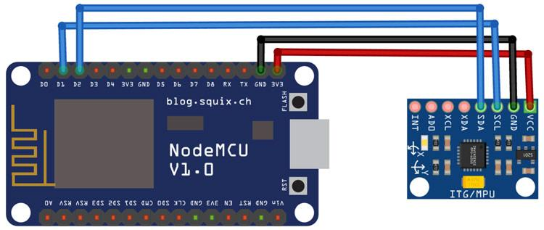

**USER INTERFACE-**

The following app uses Blynk Applications for creating its app interface which gets sensor data of accelerometer and gyroscope based on the code and use of MPU-6050, which actually applies to the threshold values of angle change and acceleration data to predict a fall and simultaneously sends a notification to the Blynk App whenever fall is detected.

The app interface is simple and easy to use for people of all ages.

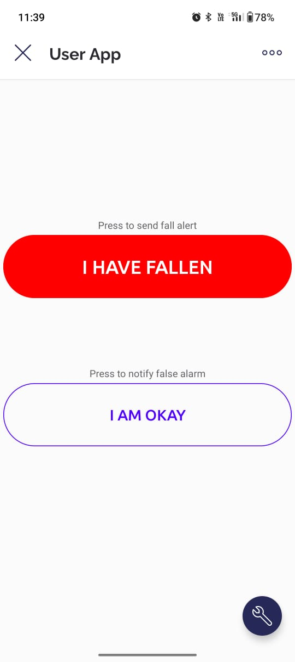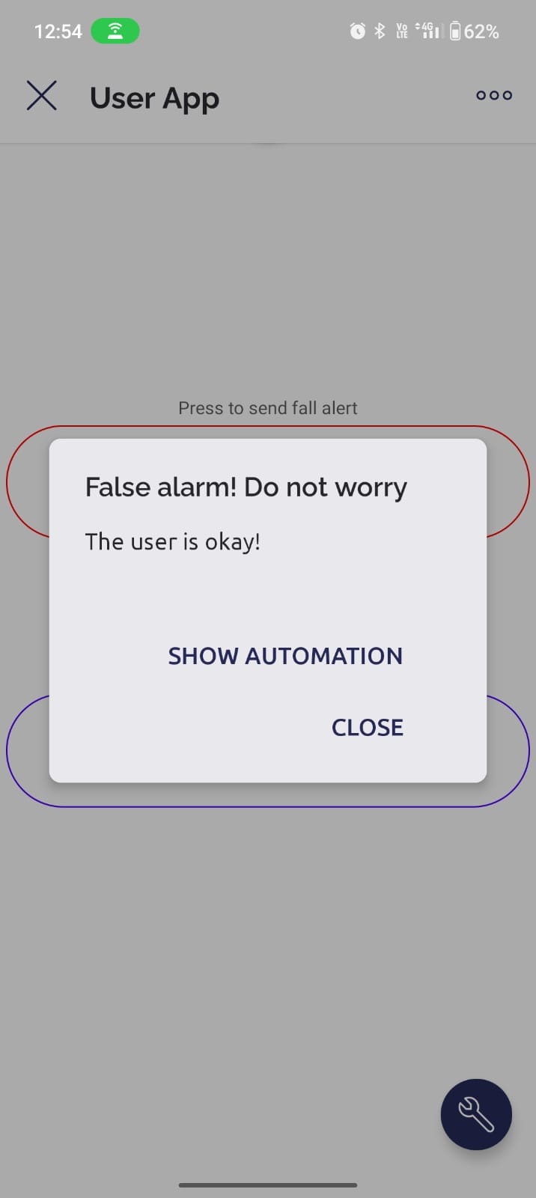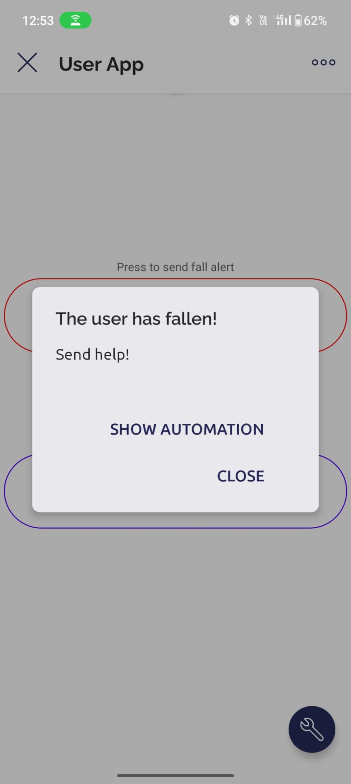

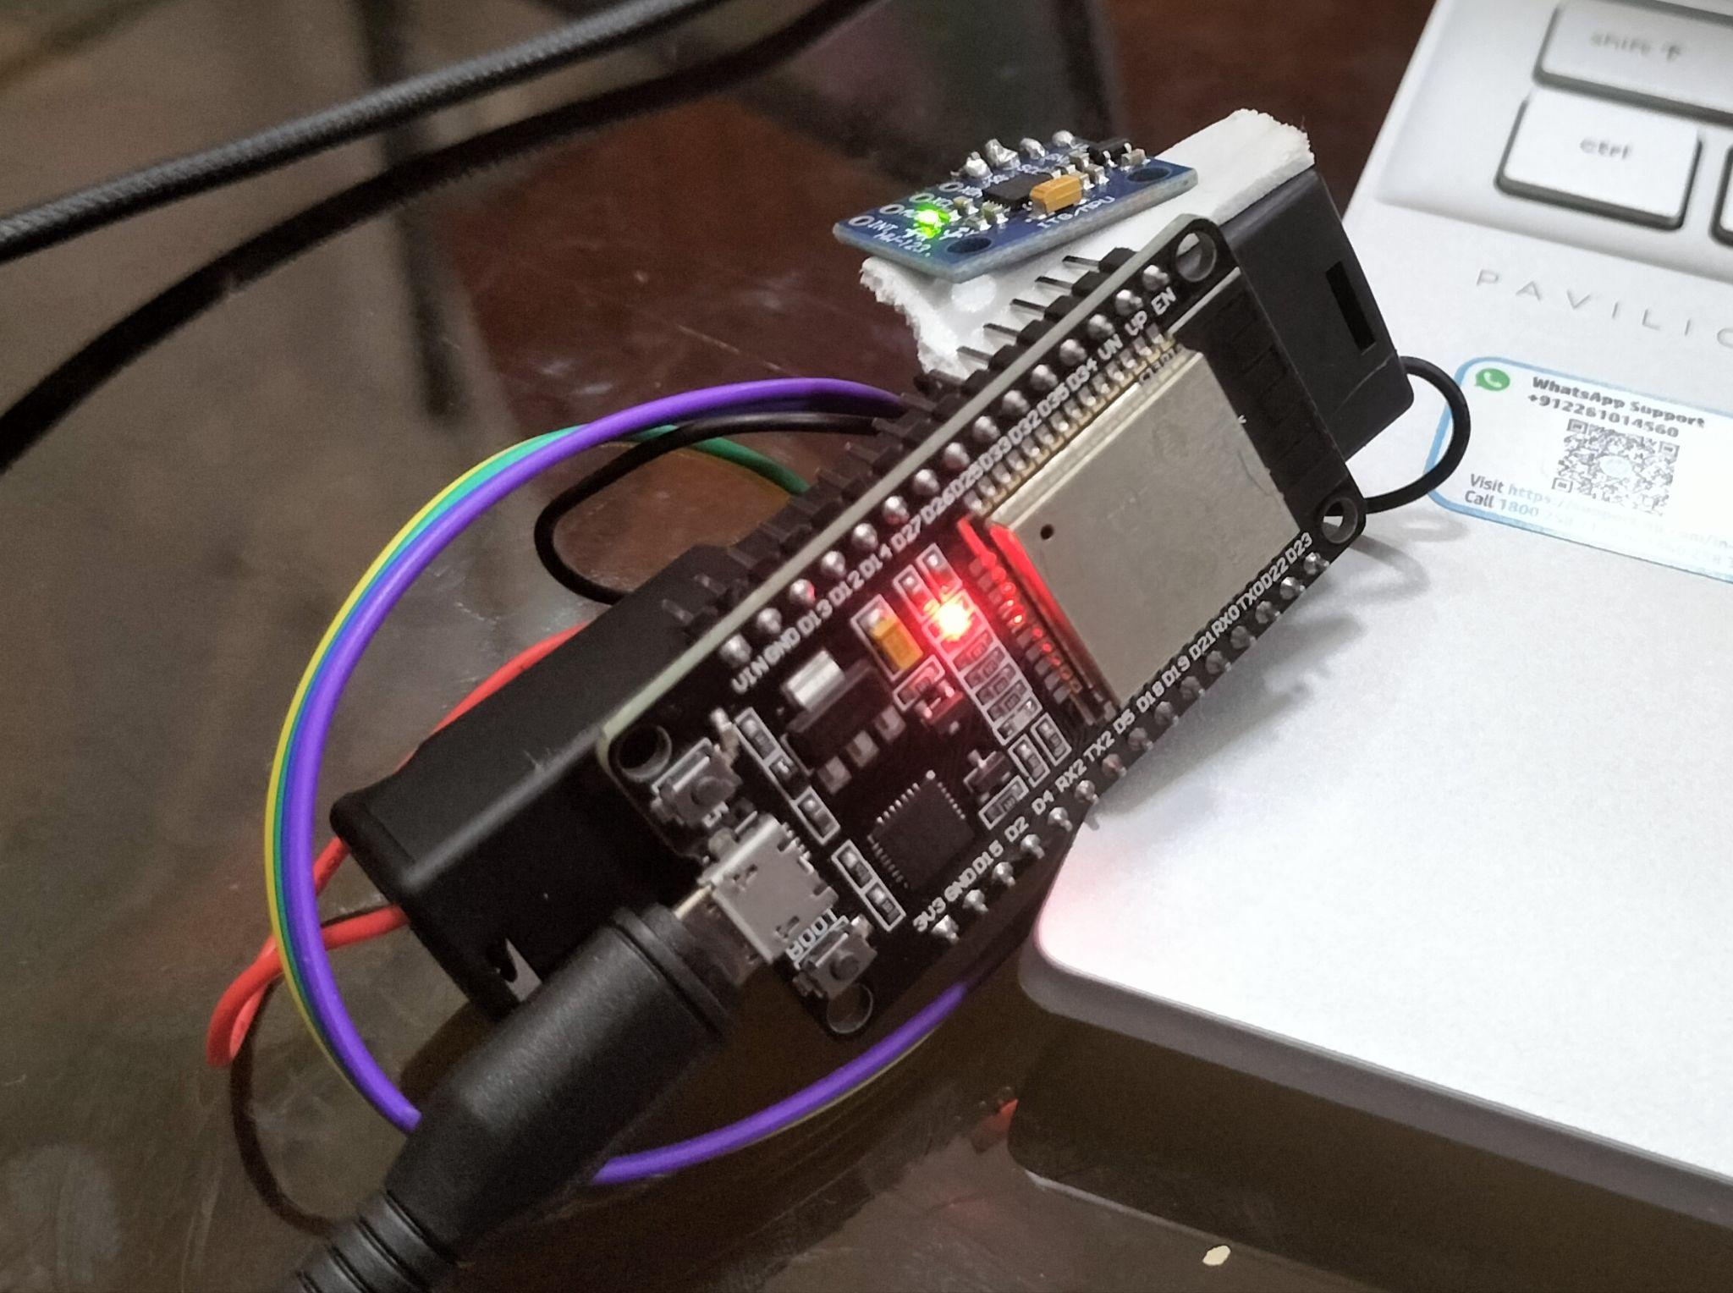

**FUTURE USES AND WORKING -**

Fall detection bands have the potential to assist in seeking medical help, they should not be considered a substitute for professional medical care. These bands are meant to complement existing healthcare systems and provide an additional layer of support for individuals in need.

* With more data values and user usage the working of the band can be improved based on machine-learning algorithms.
* The app interface can also be updated time to time to implement the new challenges faced by elderly people.
* Fall detection bands can be valuable during the recovery process after surgery or medical procedures. They can help monitor patients' movements and detect falls, reducing the risk of post-operative complications.
* For individuals with chronic diseases such as epilepsy, diabetes, or heart conditions, fall detection bands can monitor for falls or episodes related to their condition. By detecting such incidents, the band can automatically notify medical professionals or caregivers who can provide timely assistance.

The rapid growth of IOT and health care industry is projected to reach $67.2 billion by 2027 driven by the increasing adoption of wearable devices for remote patient monitoring and personal safety.(Source-Grand View Research)

**Conclusion:**

This code uses an ESP8266 and MPU-6050 sensor to detect falls. It processes accelerometer and gyroscope data, applies thresholds and angle changes to identify falls, and sends notifications through Blynk when a fall is detected.

**References:**

<https://iotdesignpro.com/projects/iot-based-fall-detection-system-using-nodemcu-esp8266-and-accelerometer-mpu6050>

<https://iotprojectsideas.com/iot-fall-detector-using-mpu6050-esp8266/>

**Our Presentation:**

<https://www.canva.com/design/DAFksbEQKUQ/ZbwBd-wd3t5zl_6YJOBxIg/edit?analyticsCorrelationId=a770a41a-92e0-4065-a7f6-b522b2740e17>

**YouTube Video:**

[**https://youtu.be/D_lCHMulE0g**](https://youtu.be/D_lCHMulE0g)

.